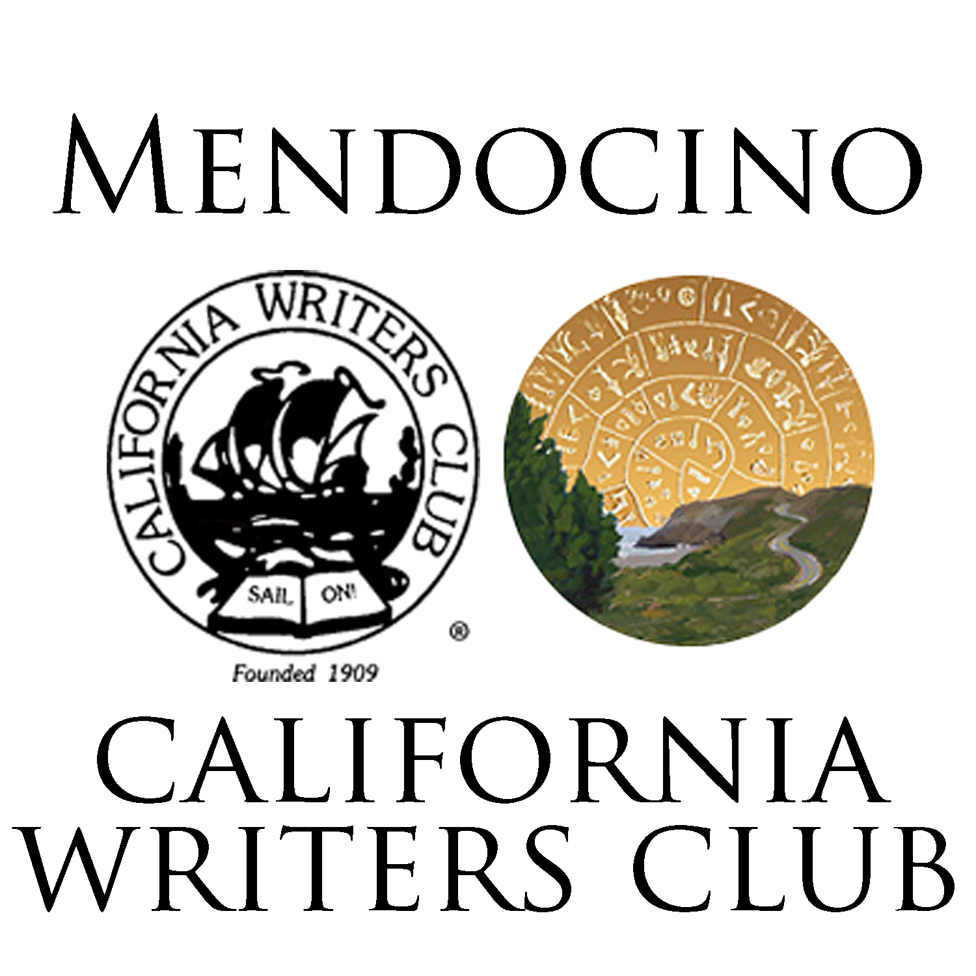

WRITERS OF THE MENDOCINO COAST
NEW MEMBERSHIP--$65 (July 1-June 30)
Youth Membership (ages 14-22)--$20
Includes an automatic membership in the California Writers Club
Questions? Contact membership@writersmendocino.org
Make check payable to Writers of the Mendocino Coast and send to:
WMC
P O Box 762
Fort Bragg, CA 95437

Please print legibly and send the form below with your check.
---------------------------------------------------------------------------------------------
Name: ____________________________________________________
Email: _____________________________________________________
Address: ___________________________________________________

Phone (optional): ___________________________________________
Your writing genre: __________________________________________

